Office Accessibility- Manchester

Accessibility Guide for Sage- Manchester.
Exchange Key, Salford.
https://www.sage.com/en-gb/about-us/contact-us/
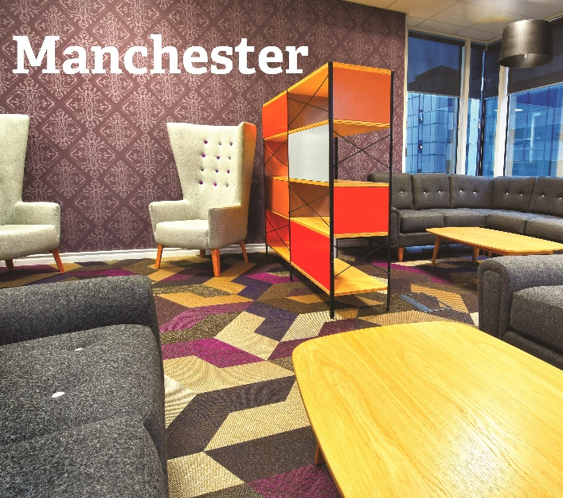

Welcome
This guide will help you work through the accessible office information for our Manchester office.



Path to main entrance

- Main entrance accessible through outside lift (102cm wide).

 Before entering

Designated accessible parking (under building 1).
Main entrance doors are 91cm wide (manually operated).
Access control suitable for wheelchair user.
Access control suitable for wheelchair user.


Level Access

Main entrance accessible through outside lift (102cm wide).

There is level access from the main entrance to:

Accessible toilet (manually operated via 90cm door).
Bistro dining area (manually operated via 90cm door).
Multi- faith room and quiet room (manually operated via 90cm door).
Elevator area.


Lifts / Elevators

Access to all floors via passenger lifts.
Lift doors are 91cm wide, lifts are 91cm wide and 133cm deep.
Lift buttons are raised.
Lifts will show floor numbers at each floor.
Lifts will announce whether it is going up or down and when doors open or close.


Accessible toilets

Toilet doors are manually operated and 90cm wide.
Direction of travel for female toilets are to the right and left for male toilets.
Toilet height is 36cm with handrails.
There is 30cm at the side of the toilet. There is 137cm in front of the toilet.


Bistro dining area

There is no background music played in the cafeteria.
Easily accessible allergen information provided if asked.
Cater for specific diets (e.g., gluten free, vegan, vegetarian).


Hearing

The fire alarm has flashing lights.
There are no hearing loop systems installed within this site.


Visual

Glass doors and full-height windows have contrast markings.
The walls and the doors do not have high colour contrast (painted white).
Low lighting is not standard.



Neuro-inclusive

No designated quiet working areas.
Light brightness can be adjusted in multi-faith room.
No patterns on walls and floors.
Spaces without patterned wall and floor surfaces.


General

Hot desking (need prior notice to accommodate designated working space).
Two high adjustable desks located on the ground floor.
Evacuation Chairs available on ground and first floor.


Assistive dogs

No provision for assistive dogs, for example space for toileting, water/feeding stations.
Door handles are not easy grip and accessible.
Access controlled release buttons accessible for a wheelchair user.

Getting here
1 Exchange Quay,
Salford
M5 3EA


Parking

There is a designated parking space at the venue.

Customer care support

Emergency evacuation procedures
We have emergency evacuation procedures for disabled visitors.
The fire alarm does not have flashing lights.

Guide last updated: March 2023.

